EE 97 Fall 2016

Thurs. 1330

Lab #8: AM Radio Receiver

Sidarth Shahri

Partner: Christian Lopez

Station 10

Submitted December 8, 2016

Lab #8: AM Radio Receiver Report

**Experiment 1**

When some current flows through a wire, it emits an electromagnetic wave. When an electromagnetic wave contacts another wire a small amount of voltage is induced on this wire. Using this simplified principle, a simple radio can be built to send and receive sound. A circuit is shown below that converts sound waves to electrical current, sends it via electromagnetic waves to another circuit which then outputs the sound via a speaker.

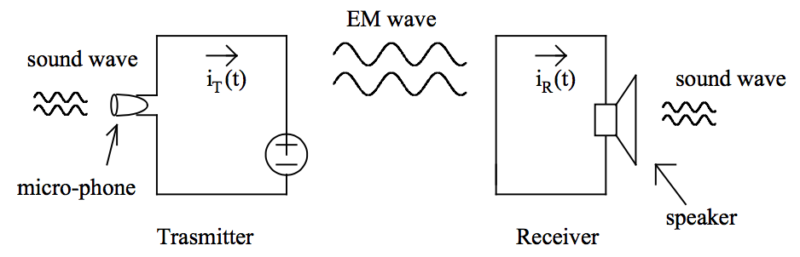

However, over long distances, simply converting sound waves to an electrical signal will not suffice. In addition, there are tons of different electromagnetic waves in the air. A circuit must be used to increase the frequency of the electric current produced by the sound waves and to receive the correct electromagnetic wave. In experiment 1, we focused on the receiver circuit. We examined how an amplifier works.

Measurements were taken in ENG 249 Station 10 on Thursday, November 17, 2016 using:

* Agilent Digital Multimeter 34405A (S/N: TW48090264)
* Tektronix DPO 3012 Oscilloscope (S/N: C010914)
* Agilent Function Generator 33220A (S/N: MY44042788)
* LC318 Op-Amp

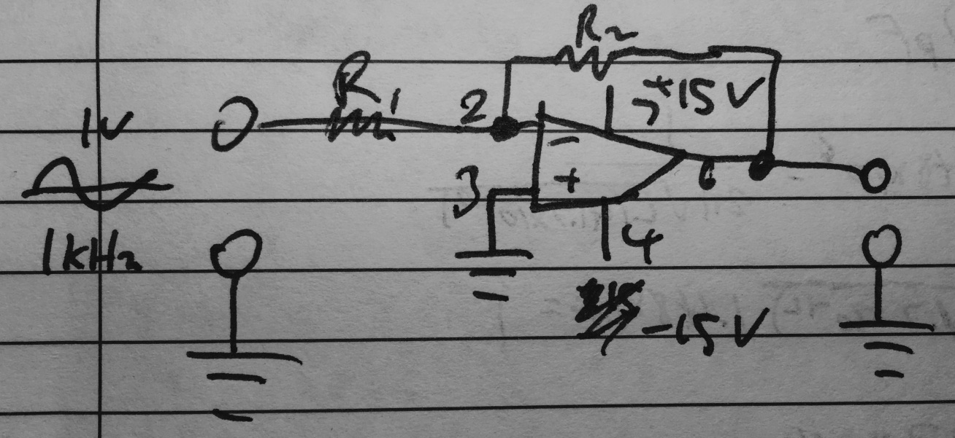

Inverting Op-Amp Circuit

Gain: 10

R1 = 1kΩ

R1 (actual) = 0.9770kΩ

R2 = 10kΩ

R2 (actual) = 9.7767kΩ

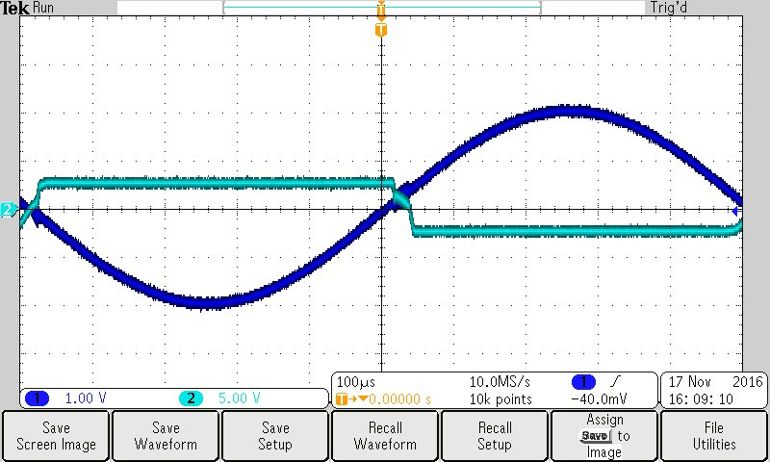

Inverting Op-Amp Circuit Output

To find the amplifier’s maximum output current, simply add a load resistor to a non-inverting op-amp circuit and test the current output.

An op-amp circuit serves to amplify the input. Using external power, the voltage is amplified within a certain range of the op-amp. Current will vary according to V=IR. The two types of op-amps used are non-inverting and inverting op-amps.

**Experiment 2**

In this experiment, we use the amplitude modulation of the function generator to display a modulated waveform on the oscilloscope. An audio signal can be carried much further with a carrier frequency with a high frequency.

Measurements were taken in ENG 249 Station 10 on Thursday, December 1, 2016 using:

* Tektronix DPO 3012 Oscilloscope (S/N: C010914)
* Agilent Function Generator 33220A (S/N: MY44042788)
* LM318 Op-Amp

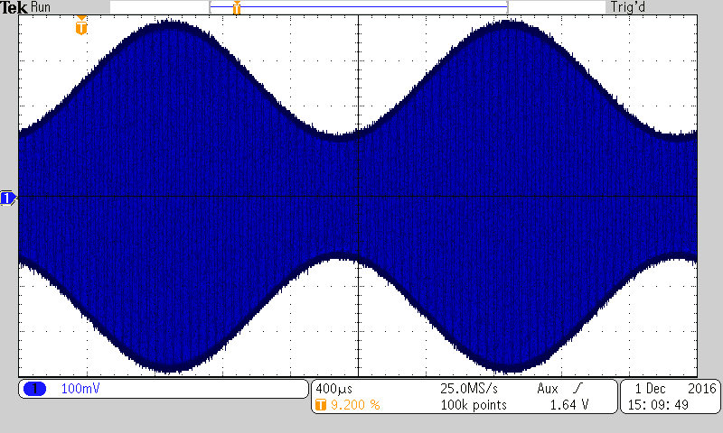

Waveform of a 1MHz AM frequency with 100k points

Amplitude modulation is a fantastic way to send sound signals over electromagnetic waves over large distances. By using a very high carrier frequency to carry the audio signal and a receiver AM circuit to remove the carrier frequency, an audio signal can travel long distances without losing much fidelity.

**Experiment 3**

In this experiment, we use an LC circuit to tune to a frequency generated by a function generator and display the output on an oscilloscope without making direct wiring contact between the LC circuit and the function generator. An LC circuit can resonate when tuned to the correct frequency matching the carrier frequency of an AM waveform. Using this principle, an LC circuit can be tuned with a variable capacitor and a variable length of wire acting as an antenna to find a specific electromagnetic wave.

The resonant frequency of an LC circuit is given by:

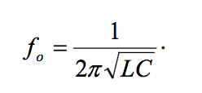

Measurements were taken in ENG 249 Station 10 on Thursday, December 1, 2016 using:

* Agilent Digital Multimeter 34405A (S/N: TW48090264)
* Tektronix DPO 3012 Oscilloscope (S/N: C010914)
* Agilent Function Generator 33220A (S/N: MY44042788)
* Capacitance Meter – 830 Auto-ranging Meter (BK Precision) (S/N: 07299070052)
* LM318 Op-Amp
* Inductor ~ 250mH
* Variable Capacitor (S/N: CV2313910R) ~ 30pF – 430pF

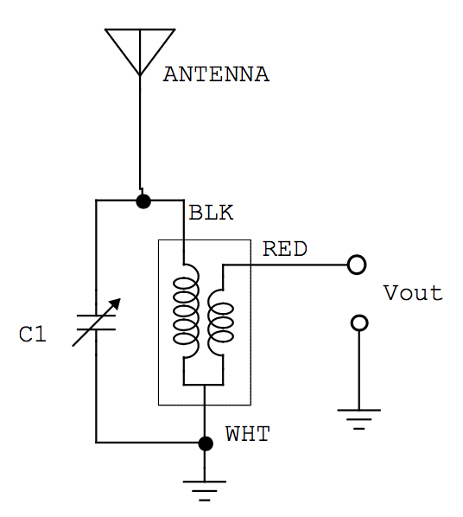

Circuit used for Trial 1 and Trial 2. Note that the function generator was put near the antenna.

**Trial 1**

f = 1/[(2pi)(sqrt(LC))] = 1/[(2pi)(sqrt(250mH*42pF))] = 1.48MHz

Actual inductance of the inductor was found to be about 277mH.

Voltage from scope: 11.04mV

|  |  |
| --- | --- |
| Carrier Frequency (MHz) | Voltage (mV) |
| 1.29 | 0.42 |
| 1.3 | 0.42 |
| 1.31 | 0.425 |
| 1.32 | 0.426 |
| 1.33 | 0.431 |
| 1.34 | 0.434 |
| 1.35 | 0.44 |
| 1.36 | 0.44 |
| 1.37 | 0.449 |
| 1.38 | 0.455 |
| 1.39 | 0.468 |
| 1.4 | 0.484 |
| 1.41 | 0.502 |
| 1.42 | 0.532 |
| 1.43 | 0.584 |
| 1.44 | 0.637 |
| 1.45 | 0.785 |
| 1.46 | 1.332 |
| 1.47 | 4.639 |
| 1.48 | 10.564 |
| 1.49 | 6.936 |
| 1.5 | 2.148 |
| 1.51 | 0.861 |
| 1.52 | 0.655 |
| 1.53 | 0.568 |
| 1.54 | 0.52 |
| 1.55 | 0.486 |
| 1.56 | 0.468 |
| 1.57 | 0.452 |
| 1.58 | 0.445 |

Graph of Frequency vs. Voltage

**Trial 2**

f = 912kHz

C = 121pF

|  |  |
| --- | --- |
| Carrier Frequency (kHz) | Voltage (mV) |
| 852 | 0.497 |
| 862 | 0.538 |
| 872 | 0.607 |
| 882 | 0.75 |
| 892 | 1.316 |
| 902 | 4.194 |
| 912 | 14.358 |
| 922 | 4.028 |
| 932 | 1.213 |
| 942 | 0.717 |
| 952 | 0.582 |
| 962 | 0.518 |
| 972 | 0.488 |

Experiment 3 demonstrates how effective an LC circuit can be in tuning to a certain frequency. Only if the LC circuit is tuned to a very specific frequency will the circuit resonate with the transmitted radio frequency you are looking for. Other frequencies will not affect the LC circuit.

**Experiment 4**

In this experiment, we combine the op-amp and the LC circuit to attempt to tune to a live radio station. The output will then be played via speakers. We will be tuning the LC circuit in an attempt to find a radio frequency that works.

Measurements were taken in ENG 249 Station 10 on Thursday, December 1, 2016 using:

* Agilent Digital Multimeter 34405A (S/N: TW48090264)
* Tektronix DPO 3012 Oscilloscope (S/N: C010914)
* Agilent Function Generator 33220A (S/N: MY44042788)
* HP 33631A Triple Output (S/N: KR09017880)
* Capacitance Meter – 830 Auto-ranging Meter (BK Precision) (S/N: 07299070052)
* LM318 Op-Amp
* Inductor ~ 250mH
* Variable Capacitor (S/N: CV2313910R) ~ 30pF – 430pF

Here is the circuit built on the breadboard:

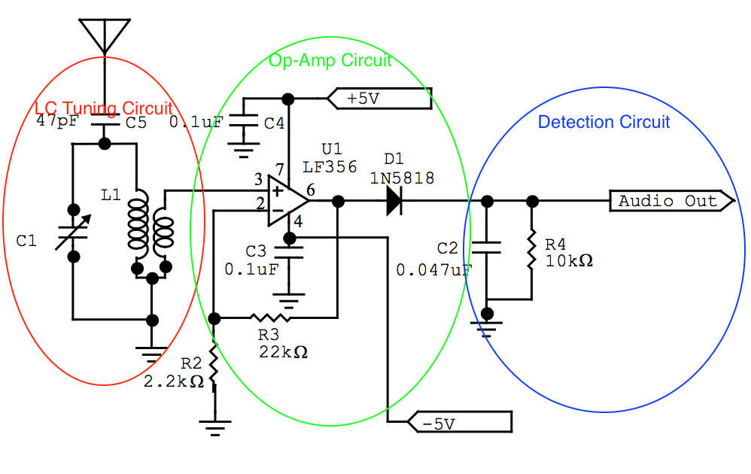

Using this circuit, we could tune to only Desi 1170 AM. Below is the output displayed on the oscilloscope. Most of the output is jumbled due to the nature of the voice and music signals sent through the radio.

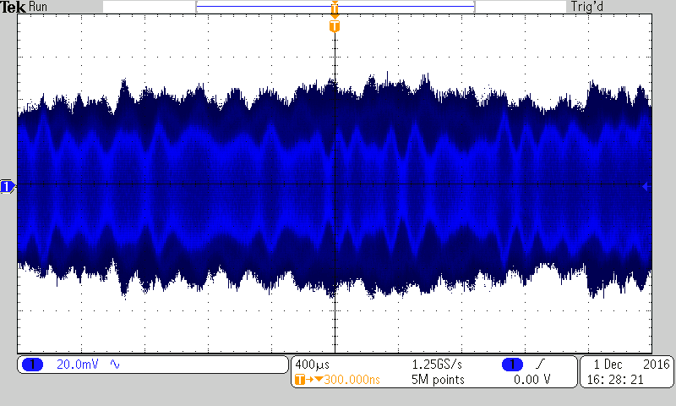

Below is the output of the LC tuning circuit. Note that the op-amp circuit amplifies this output.

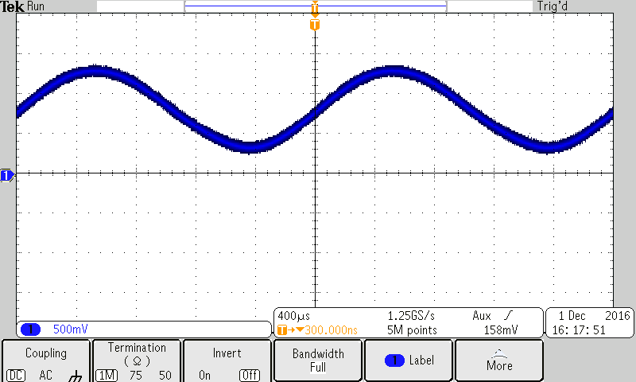

**Conclusion**

Throughout this lab, we learned about the different parts of an AM radio receiver circuit. The op-amp circuit amplifies the output of any input. It will amplify the voltage so long as the input is within a certain range. It uses external power to amplify the input. The LC circuit is used to tune to a specific radio station by resonating with the input radio frequency. A variable capacitor can be used to tune the circuit to resonate with a different station thereby tuning the “radio.” Put together, you can use the circuit to tune to a specific radio station depending on the length of wire in the antenna, the inductor, and the capacitor.